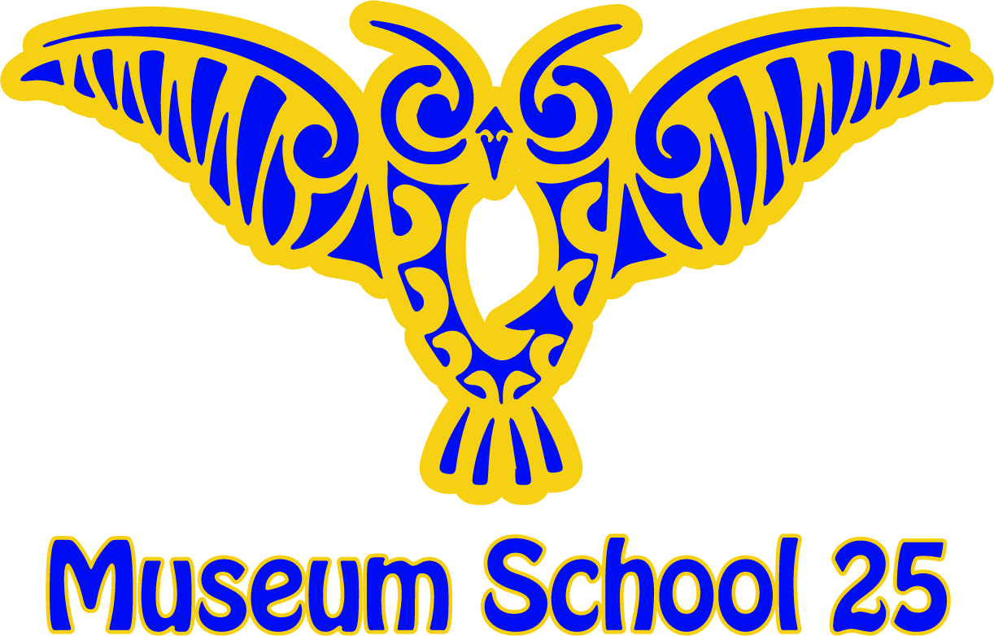

JoAnn DiMaria 579 Warburton Avenue•Yonkers•NY•10701 Sylvia Branchcomb
Principal (914) 376-8450 Assistant Principal
______________________________________ _________________________________________________

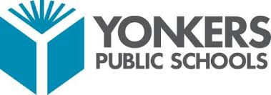
School Spirit Days
2018-2019
October 26, 2018 -----------→ Halloween Dance Day
(Bring your favorite Halloween costume)

November 30, 2018 ----------→ Mismatch Day
(Dress in mismatched clothes, shoes, socks)

December 21, 2018 ----------→ Pajama Day
(Wear PJs& bring a stuffed animal)

January 25, 2019 -----------→ Sports Team Day
(Wear your favorite team gear)

February 14, 2019 ----------→ Crazy Heart Day
(Wear red, pink or white)

March 1, 2019 -------------→ Dr. Seuss Day
(Wear a shirt you can read)

March 29, 2019 ------------→ Superhero Day
(Wear your favorite Superhero attire)

April 26, 2019 -------------→ Collegiate Day
(Wear any college gear)

May 31, 2019 -------------→ Blast From the Past Day
(Dress like you’re from the 70’s,80’s or 90’s)

June 21, 2019 -------------→ Beach Day
(No Swimsuits!)

